DATA TYPES IN JAVA
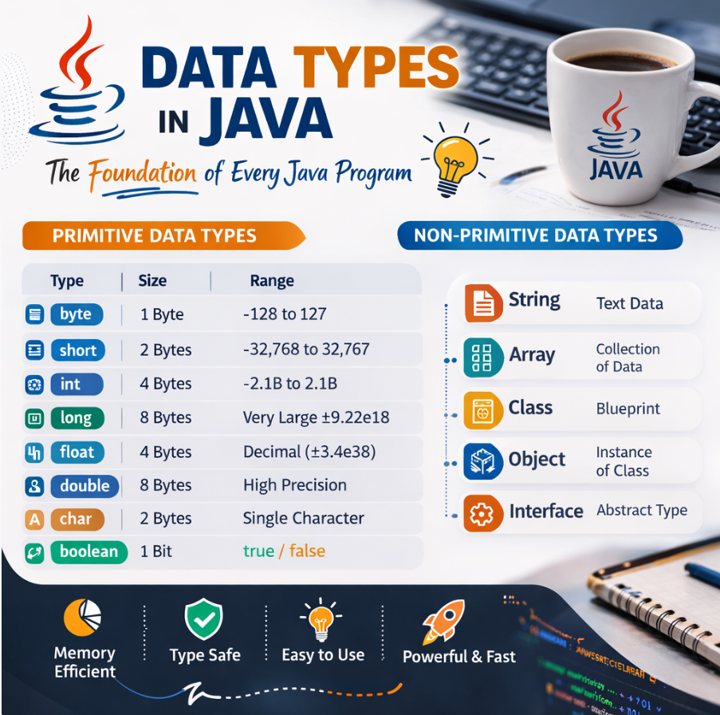

📊 Data Types in Java :
In Java, data types specify the type of values a variable can hold. They define the size, range and nature of data stored in memory. Java has two main categories of data types :
1.Primitive data types : byte, short, int, long, float, double, char, boolean.
2.Non-Primitive data types: String, Arrays, Classes, Interfaces, Objects.

Java Data Types
│
├── Primitive Data Types
│ ├ byte
│ ├ short
│ ├ int
│ ├ long
│ ├ float
│ ├ double
│ ├ char
│ └ boolean
│
└── Non-Primitive Data Types
├ String
├ Array
├ Class
├ Interface
└ Object

🔹 1️⃣ Primitive Data Types :
Primitive data types are the basic built-in data types in Java.
They store actual values directly in memory and are very fast and memory efficient.
Java has 8 primitive data types.

✔ stored directly in memory
✔ fixed memory size
✔ very fast
✔ not objects

Java has 8 primitive data types
byte
short
int
long
float
double
char
boolean

1.byte
Meaning
byte is used to store very small integer numbers.
Memory Size
1 byte = 8 bits
Range
-128 to 127
Example
byte age = 25;
Memory Explanation
A byte uses 8 bits
00000000
Maximum positive value:
01111111 = 127
Minimum value:
10000000 = -128
Use Case
Used in
- file handling
- network streams
- large arrays to save memory

2.short
Meaning
short stores small integer numbers but larger than byte.
Memory Size
2 bytes = 16 bits
Range
-32,768 to 32,767
Example
short temperature = 200;
Use Case
Used when numbers are not too large but bigger than byte.
Example:
- small counters
- sensor values

3.int
Meaning
int is the most commonly used integer type in Java.
Memory Size
4 bytes = 32 bits
Range
-2,147,483,648 to 2,147,483,647
Example
int salary = 50000;
Why int is used most
Because it balances:
- memory usage
- performance
- range
Use Cases
- loops
- counters
- calculations
- indexes
Example:
for(int i = 0; i < 10; i++)
{
System.out.println(i);
}

4.long
Meaning
long is used for very large integer numbers.
Memory Size
8 bytes = 64 bits
Example
long population = 8000000000L;
Note:
L is added to tell Java that the number is long.
Use Cases
- world population
- timestamps
- bank transactions
- large IDs

5.float
Meaning
float stores decimal numbers (single precision).
Memory Size
4 bytes
Example
float price = 19.99f;
Note:
f is required because decimal numbers are double by default in Java.
Example Values
3.14
12.5
0.75
Use Cases
- graphics
- measurements
- scientific calculations

6. double
Meaning
double stores decimal numbers with higher precision than float.
Memory Size
8 bytes
Example
double pi = 3.14159265359;
Why double is preferred
Because it provides more accuracy.
Use Cases
- financial calculations
- scientific data
- precise mathematics

7.char
Meaning
char stores a single character.
Memory Size
2 bytes
Java uses Unicode for characters.
Example
char grade = 'A';
Important:
Character must be inside single quotes
'A'
'B'
'9'
'@'
Unicode Example
'A' = 65
'B' = 66
Use Cases
- text processing
- storing letters
- symbol representation

8. Boolean
Meaning
boolean stores true or false values.
Example
boolean isJavaFun = true;
Possible values
true
false
Use Cases
Used in decision making
Example:
boolean isLoggedIn = true;
if(isLoggedIn)
{
System.out.println("Welcome User");
}

🔹 2. Non-Primitive Data Types
Non-primitive types are also called Reference Data Types.
Instead of storing the value directly, they store the memory address (reference).
Examples:
String
Array
Class
Interface
Object

1. String
Used to store text data.
Example:
String name = "Omkar";
Strings are actually objects in Java.

2.Array
An array stores multiple values of the same type.
Example:
int numbers[] = {10,20,30,40};
Memory view:
numbers
|
|---- 10
|---- 20
|---- 30
|---- 40

3. Class
A class is a blueprint to create objects.
Example:
class Student
{
int age;
}

4.Object
Object is an instance of a class.
Example:
Student s1 = new Student();
Here
Student → class
s1 → object
Exploring Java Data Types Through a Simple Demo Application : -
public class DataTypesDemo {
public static void main(String[] args) {

// -------- Primitive Data Types --------
byte b = 100; // 1 byte
short s = 30000; // 2 bytes
int i = 100000; // 4 bytes
long l = 10000000000L; // 8 bytes

float f = 3.14f; // 4 bytes
double d = 3.14159265359; // 8 bytes

char c = 'A'; // 2 bytes (Unicode character)
boolean flag = true; // 1 bit

// -------- Non-Primitive Data Types --------
String str = "Hello, Java"; // String (class in Java)
int[] arr = {1, 2, 3, 4, 5}; // Array
Integer wrapperInt = Integer.valueOf(50); // Wrapper class example
StringBuilder sb = new StringBuilder("Java"); // Class object

// -------- Output --------
System.out.println("byte: " + b);
System.out.println("short: " + s);
System.out.println("int: " + i);
System.out.println("long: " + l);
System.out.println("float: " + f);
System.out.println("double: " + d);
System.out.println("char: " + c);
System.out.println("boolean: " + flag);

System.out.println("String: " + str);
System.out.print("Array: ");
for (int num : arr) {
System.out.print(num + " ");
}
System.out.println();

System.out.println("Wrapper Integer: " + wrapperInt);
System.out.println("StringBuilder: " + sb);
}
}

Difference between primitive and non -primitive Data types ?
Feature | Primitive Data Types | Non-Primitive Data Types
Definition | Basic built-in data types provided by Java | Complex data types created using classes
Data Stored | Stores actual value directly | Stores reference (memory address) of the object
Memory Size | Fixed memory size | Memory size can vary
Performance | Faster because value is stored directly | Slightly slower due to reference handling
Number of Types | Only 8 types | Unlimited types
Created By | Predefined by Java language | Created by programmers or Java libraries
Methods | Do not have methods | Can have methods and properties
Null Value | Cannot store null | Can store null
Example Types | byte, short, int, long, float, double, char, boolean | String, Array, Class, Object, Interface
Storage Location | Usually stored in stack memory | Stored in heap memory

